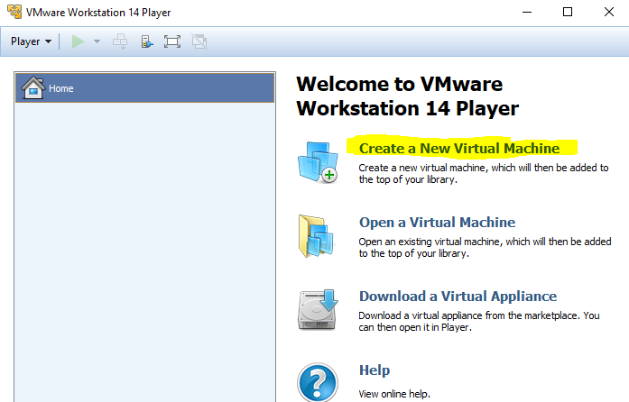

Use the Browse… button to tell Workstation Player where the ISO file lives.

**Note**: When Workstation Player recognizes the OS it is about to install, it will offer you the choice to use “Easy Install.” This allows you to pre-enter the data the installation will need, such as computer name, user name, keyboard type, etc. It will then enter those items for you when the OS installs, which speeds the installation process. If you want to see the questions the OS asks during installation and answer them yourself, select “I will install the operating system later.” You will have to connect the VM to the installation ISO manually, and then the installation will proceed just as it does on fresh hardware.

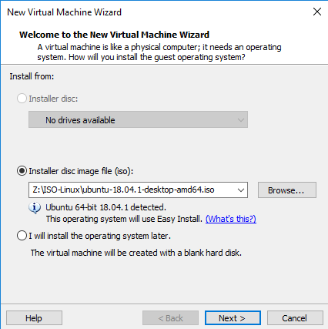

Linux user names must be lower case letters. Don’t forget your password!!

You can use a simple password here, unless you plan to store secrets on the VM.

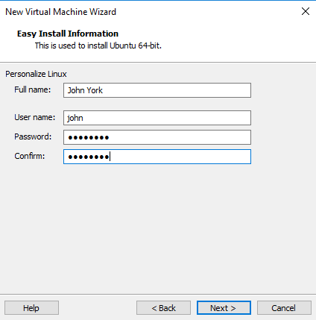

The standard location is C:\Users\[your user name]\Documents\Virtual Machines, which is fine. Give the VM any name you like, within reason.

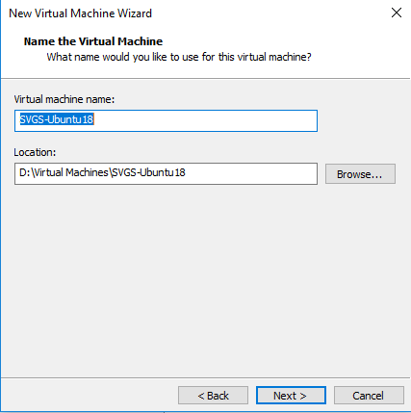

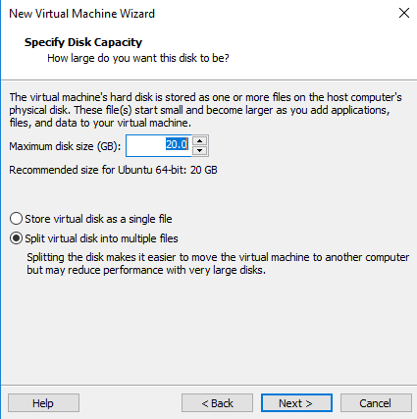

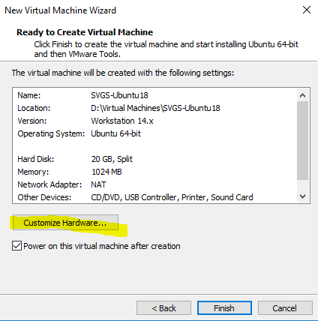

Your VM will run better if you give it 2 CPUs and 4 GB of RAM

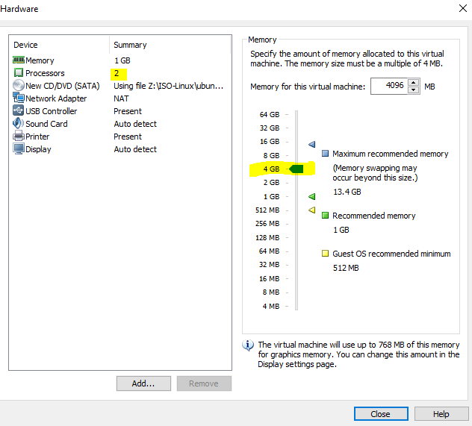

At this point, the installation will proceed on its own, and you should eventually see an Ubuntu login screen.

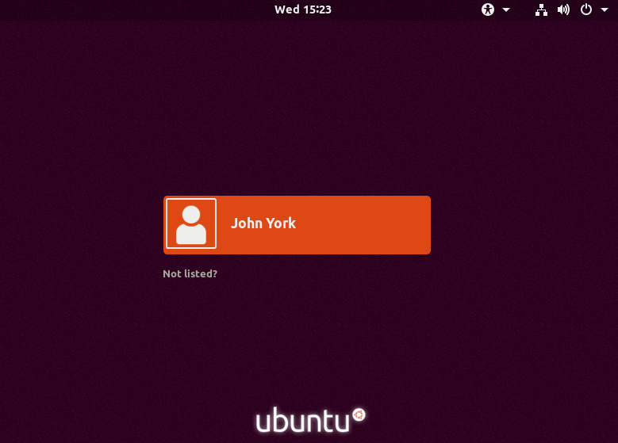

# Note: If you elected not to use Easy Install, or, Installing Ubuntu the hard way

If you told Workstation Player that you would install the OS later, you will find the VM fails to boot because it cannot find media.

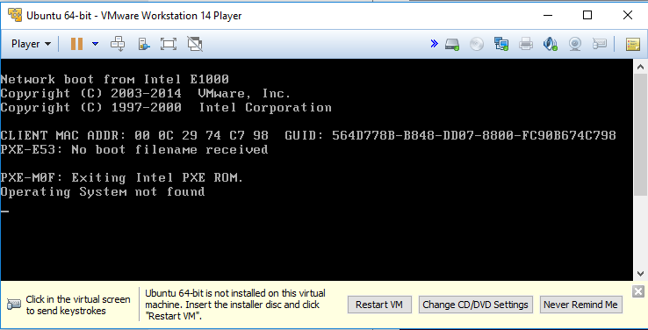

Fix that by using the VM settings to tell the VM to boot from the installation ISO. You can click on “Change CD/DVD Settings.” Be sure the Device status is Connected and Connect at power on. Use the browse button to find the ISO file you wish to install.

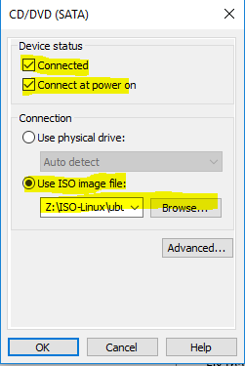

**Or**, you can select Player > CD/DVD > Settings

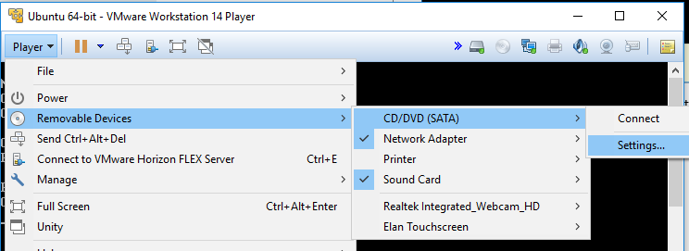

Then make the same settings as before.

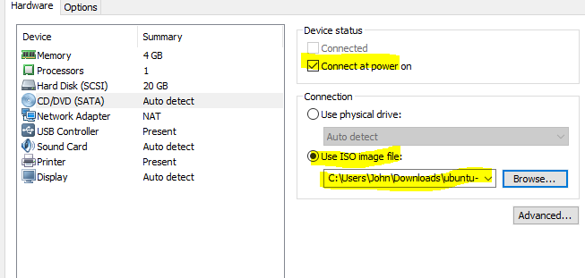

When the VM boots, it should start the installation process from the ISO file. If you select “Try Ubuntu”, the VM will boot entirely from the CD (or ISO), will always require the CD/ISO to boot, and changes you make will be lost any time the VM restarts. This is called a “Live CD” installation” and has the advantage of taking very little disc space. We will install our VM on the files in the VM folder so that we don’t need the ISO to boot (after the installation) and any changes we make will be retained between reboots.

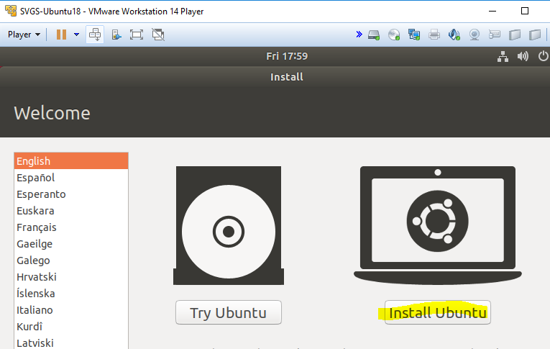

I selected the standard US English keyboard.

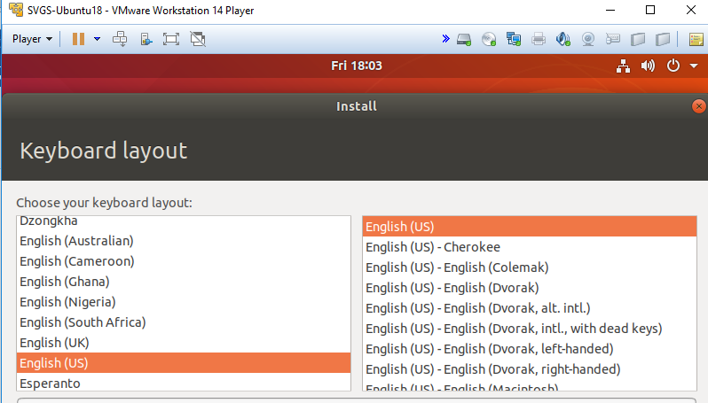

I chose to forgo the games, but that’s up to you. I also told it to download updates for Ubuntu and third-party software.

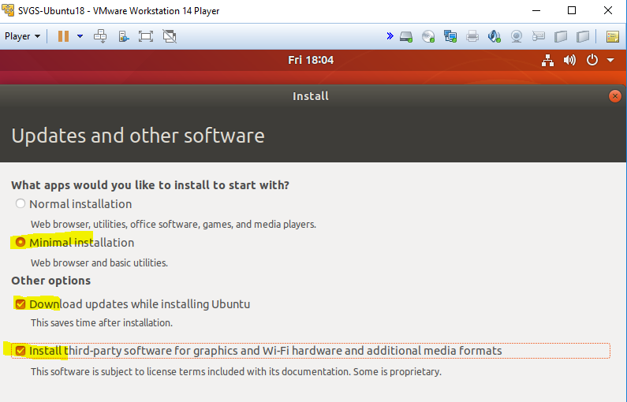

If we were installing on hardware we would want to ensure that there is nothing important on the hard disk, as it will be overwritten. On a VM, the “hard disc” is just a file that hasn’t been created yet so there is no danger of losing data. LVM is the most current disc format, but it makes the partitions look different in the command line utilities than they do for older installations. You can use it or not, as you choose.

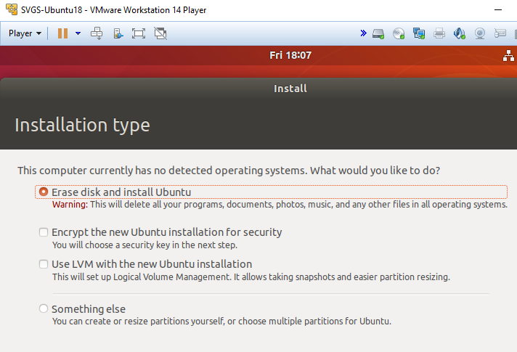

Some screens have been skipped. Note that Linux requires the username to be in lower case.

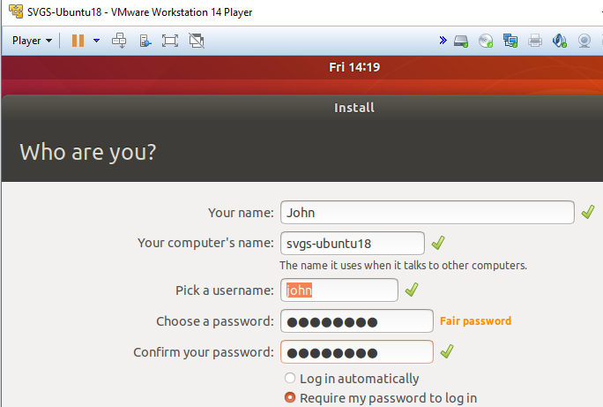

Done! (Almost)

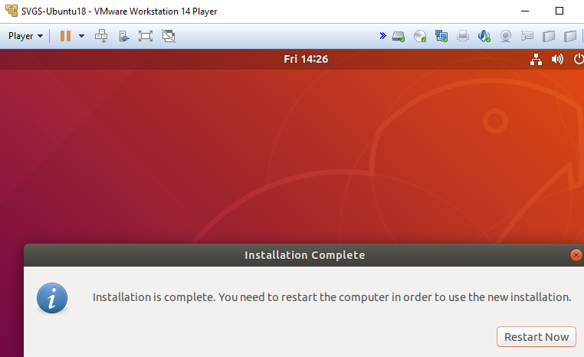

We don’t want to boot from the CD/ISO anymore, so disconnect it.

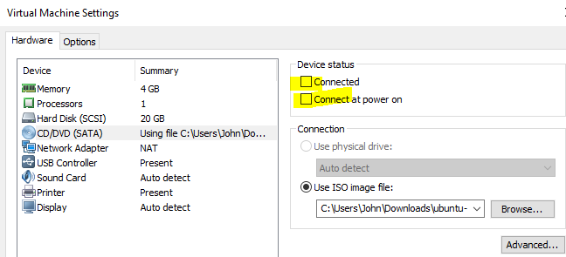

# Installing VMware Tools

VMware tools provide better drivers and software to make the OS easier to use in a VM environment. VMware Workstation Player comes with tools for several OSs, but… Let me show you the problem--**read, but don’t click for a moment**.

You can access the VMware version of the tools through the Player > Manage menu.

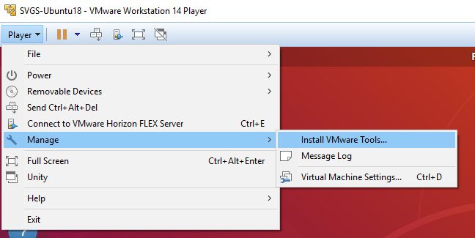

All it does is mount an ISO as a CDROM on your desktop. Right-click properties shows the folder the file lives in.

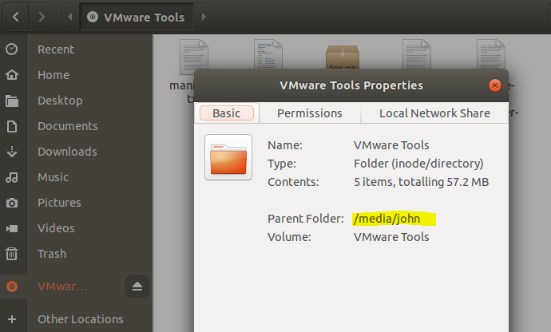

After going through a bunch of commands to copy it, unzip it, and run it, it tells you it doesn’t recommend using the VMware tools that came with Player. Instead, you should use the open-vm-tools that comes with the Ubuntu distribution. Ugh.

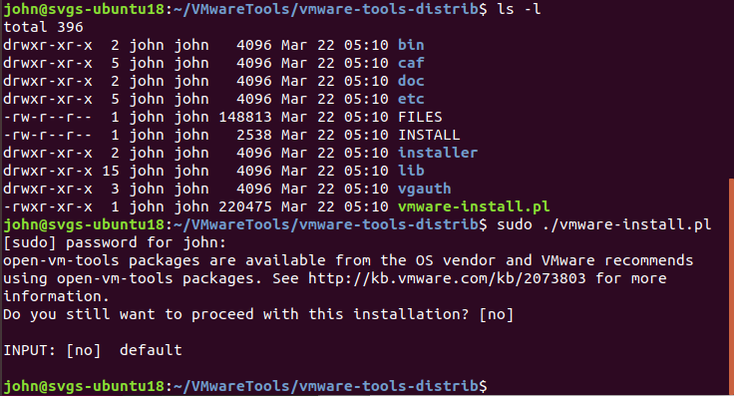

**OK, now you can click, type, whatever**.

So, now we’ll skip ahead and install open-vm-tools from the command line, very quickly. The command is:  
sudo apt-get install open-vm-tools

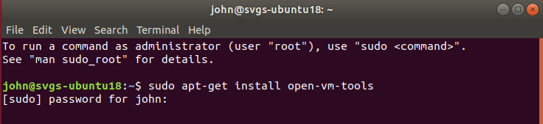

Once you put in your password and tell it to install, it will be done in moments.